Recruiting in Motion / PCR Training Guidelines

TABLE OF CONTENTS
(To quickly jump to a page, ctrl+click on the topic or page #)

Recruiting in Motion PCR Login Page 3
PCR Mobile-Link 3
Your Recruiting in Motion unique PCR Username and password 3
Internet Browser 3
Install PCRecruiter Launcher 3
Add Your People 5
Adding a Name to PCR (without a resume) 5
Adding a Resume to PCR from file-folder 5
Add/Parse resume from PCRmail: 5
‘Add Wizard’ 5
How to inhale People from LinkedIn/Facebook/Indeed into PCR 6
Adding candidate information to enter into PCR, key fields to be entered: 8
Listing of Information in PCR Dropdown Menus 11
Categories : 11
Software Skills 13
BH Industry 14
Adding Blinded-Resume (work flow) 15
Emailing 16
Send an Email from within PCR 16
Mass Email 16
Attach Files to a Record 17
Move a Name or Position to Other Company 17
How to Create a Company Target List 17
Most-Placable Candidate Presentation (with no job order in PCR) 18
George-Shin (sample candidate presentation) link 18
Email a Resume (with no video or profile) 19
Instructions to send job blast to internal users 21
Drag-n-Drop in Pipeline 23
Link Candidates to a Position 23
How to present candidate video profiles to clients 24
How do I know what my client is actually seeing in their client portal? 25
Removing Candidate from the video-section of the client portal 26
Create an Interview 28
PCR Searching – Name Search, Company Search & Position Search 29
Basic Search 29
Tips for searching fields: 29
Advanced Search 31
Activities Search 32
Rollup Lists 33
Add a Rollup 33
Add a Record to a Rollup 33
Add a Group of Records to a Rollup 33
Access a Rollup List 33
Use a Rollup List to Review & Call 34
Add a Permanent Placement 35
Add a Contract/Temp Placement 36

Recruiting in Motion PCR Login Page
Link to access PCR: https://www2.pcrecruiter.net/pcr.asp?uid=odbc.RecruitingInMotion

PCR Mobile-Link

To access PCR on your mobile device, enter the following url and follow the instructions:
http://www.pcrecruiter.net/pcrbin/rem1.aspx?db=recruiting%20in%20motion.recruitinginmotion&user=admin

Important: replace the word “admin” with your individual PCR username when saving the link.

Your Recruiting in Motion unique PCR Username and password
To be provided it to you by your direct supervisor of Office Manager. Please do not use PCR with anyone else’s username/password

Internet Browser
Although PCR is cross-browser compatible, RIM highly recommends that you access PC-Recruiter through Google Chrome.

Install PCRecruiter Launcher
PCRecruiter is a cloud based software designed to run in your browser. There are items you’ll interact with that continue to be earth based like Resumes. This poses translation issues while viewing an earth based resume in a cloud based software.
The PCRecruiter Launcher bridges that communication gap to ensure a smooth user experience. We recommended each PCRecruiter user download and install the PCRecruiter Launcher for optimal user experience. This is a one-time download, though it will prompt you to update if we’ve upgraded the file.

1. Go to your PCRecruiter login page.
2. In the System Status area, click More to download for your computer type.
3. Open the Download Folder (or place you saved the file to) and click on the folder called PCRecruiterLauncher.zip to open it
4. Click the file called PCRecruiter Launcher.exe to install

How updates work
The Launcher is a part of PCRecruiter. It will update automatically when a new version of PCRecruiter is released. You will be prompted when a new version is available. When you see this prompt, click ALLOW

Update Java
While PCR supports Chrome, the latest Internet Explorer (currently version 11), and Safari, some of the new features are only compatible in Chrome. With each of these browsers, several areas of PCRecruiter rely on Java Technology. Please make sure every PCRecruiter user is running the latest version of Java.

Click the Link below to verify your Java is current. If not, Java will prompt you to download the most recent version.
http://java.com/en/download/installed.jsp

Suggested IE Browser Settings
PCRecruiter is a full function program running in your browser. To avoid a sluggish browser, browser crash and other common problems we have compiled a list of recommended Internet Explorer Settings.

Please make sure every PCRecruiter user using Internet Explorer has the following settings:
- Open Internet Explorer
- Open the “Tools” menu, usually located at the top right-hand side of the window.
- Choose “Internet Options”
On the “General” Tab:
1. Under “Browsing History”, click on “Settings”
2. Make sure the amount of disk space to use is set at 250MB
3. Click OK
4. Click on the button that says “Delete…”
5. Check “Preserve Favorites Website Data & “Temporary Internet Files”
6. Uncheck all other Boxes
7. Click Delete
On the “Security” Tab:
1. Click on the green checkmark for “Trusted Sites”
2. Click “Sites”
3. Un-check “Require Server Verification”
4. Enter https://www2.pcrecruiter.net/pcr.asp?uid=odbc.RecruitingInMotion
5. Click “Add”
6. Click “Close
7. Click on “Default Level” and drag the bar to “Low”
On the “Advanced” Tab
1. Un-check “Enable Third Party Browser Extensions”
2. Click “Apply”
3. Click “OK”

Add Your People
These are your candidates and hiring authorities and employees working at companies. All names must be associated with a company record. All candidates will be associated with the company record titled “Candidates”.

Adding a Name to PCR (without a resume)
Use this method to add your contacts for a company or a candidate (without using a resume).
1. Click the Company icon on your Main Toolbar to open your Company Menu
2. Use the search area to find the person’s current company, or click the Display Default Company action icon.
-From the Company Results page, select Add Name in the I Want To… column.
-Or, click the company name then select the Add New Name action icon.
3. Enter the name details. Use the Status dropdown to specify the type of contact (i.e. candidate or hiring authority).
4. Click Save.

Adding a Resume to PCR from file-folder
Use this method to add a resume to the database. This process will create the name record and associate the resume in one step.
1. Click the Company icon on your Main Toolbar to open your Company Menu
2. Use the search area to find and open the person’s current company, or click the Display Default Company action icon.
-From the Company Results page, select Add Resume in the I Want To… column.
-Or, click the company name then select the Add Resume action icon.
3. Click Open to browse to and select a file on your computer, or click Paste to process clipboard
contents.
4. Modify extracted information as needed. Specify Source, Position, or Rollup if needed.

Tip: If it appears that PCR is formatting poorly/incorrectly, try to tick/untick the International Parser tick-box.

5. Click Save. Select Click to View Name Record to add details to the record.

Add/Parse resume from PCRmail: Click Add to PCR next to the resume file attached to an email. Follow steps 3-5 above.

‘Add Wizard’
At the top right of your PCRecruiter database (next to your user information) is the Add Wizard. This area will guide you through the steps to quickly add records to the database: Using this wizard, you can
-Add a company with or without contact, or import a list method.
-Add a name using manual entry, parse resume or import list methods
-Add a position using manual entry or import a list method.
In addition to this feature, you can also use the Company icon on the Main Toolbar to create a company, add a name to a company, or add a position to a company.

How to inhale People from LinkedIn/Facebook/Indeed into PCR

Before beginning, there are two things to remember:

1) Once the profiles are in PCR, their LinkedIn profile will be pdf'd into the attachments area of their profile

2) You can import any profile from LinkedIn but they will only include contact info if you are a first-level connection.
-------------------------------------------------------------

Following are instructions to install PCRecruiter's new Chrome Extension that will allow you to capture users from LinkedIn, Facebook (About page) and Indeed Resume Search and enter them into your database.

- To Install the PCR Capture Extension open Google Chrome and go to the following link: https://chrome.google.com/webstore/detail/pcr-capture/kelbccbdcmbjcjgfclkfhcbemegfhbho?hl=en-US

- Once on the PCR Capture screen click "Free" to install the extension
- Confirm the Extension by clicking "Add".
- Once added, go back to PCR and open a Company record and hover on the Company Name field. Or, open a Name record and hover on the Last Name field.
- Click the Social Networking icon at the right of the field.
- Click Search corresponding to the site to search. You may need to use the Login link to store your credentials for the site.
- Once the Extension is added you will see the following icon in your Address Bar when on a site that can be captured.
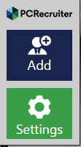
- Once you go to a site like LinkedIn, Facebook (about page) or Indeed Resume, you will see the following buttons on the Right hand side of the screen.

“Login”

- Click "Login"
- Once the Login Screen Opens you will want to enter in your PCRecruiter 9 URL (i.e. http://www2.pcrecruiter.net/pcr.asp?uid=odbc.RecruitingInMotion ) and login information and hit "Save".
- Once you are logged into the Capture Extension hit "Settings"
- In the Settings window you will want to select whether to save Captured Name Records to the Default Company or a Parsed Company – please select the company named “Candidates” and hit "Save".
- With the setup complete, you will now be able to hit "Add" when on a webpage that can be captured.

The Capture tool will parse the following fields if they are available on the LinkedIn Page:
- Title
- First name
- Last Name
- Email (parsed into Predefined Email address in PCRecruiter)
- Photo
- Location (parsed into City/state in PCRecruiter)
- Company
- Company Public URL
- Twitter
- Phone (parsed into home phone in PCRecruiter)
- Name Public URL
- Site
The Capture tool will parse the following fields if they are available on the Facebook About Page:
- First name
- Last name
- Location
- Company
- Title
- Photo
- Phone
- Name URL
The Capture tool will parse the following fields if they are available on the Indeed Resume Page:
- Title
- First Name
- Last name
- Location
- Company
- Resume (goes into Attachment screen)

Duplicate Checking:
Capture Duplicate Check for LinkedIn, Facebook and Indeed.

Scenario 1) When you import, through CAPTURE, a record from one of the 3 sites, the PCRrecord gets stamped with a profileID. When you try to import that record again it will use the profileID to duplicate check. If it finds that profileID to already exist in your database, it will then ask if you want to update that record.

Scenario 2) You have a record in your database called Liz Annable with an email address that was NOT downloaded from one of the 3 sites through Capture. You then go to one of the 3 sites to use Capture on a Liz Annable LinkedIn page. Here is what will happen for duplicate checking: It should say Add in the Capture window. If you were to add it, it would then do a search for your First and Last Name, and a search for your Email Address, to see if any of those two items return results. If the search finds matching results (first and last name OR email address), it will then ask for your input on how to proceed. If you click the name, it updates that record, otherwise it will add a new entry.

Adding candidate information to enter into PCR, key fields to be entered:
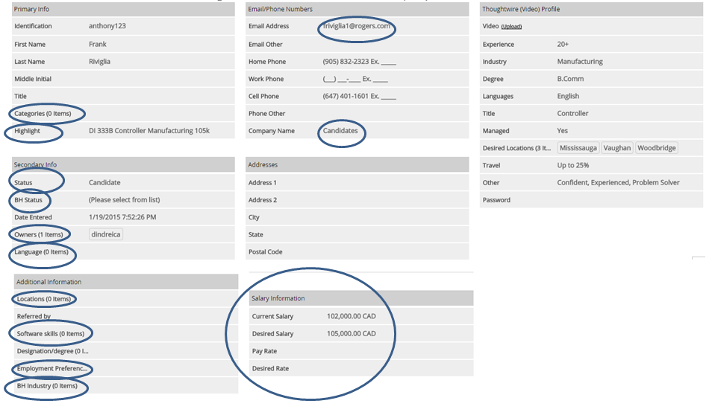

This section highlights the fields that should be entered when setting up candidates in PCR, as well as adding interview notes to ensure candidates can be found on a search.

Categories: This field consists of the types of roles the recruiter feels that the candidate would be well suited for. Select appropriate job titles that would be suited for this candidate. See table 1 for details.

Highlight line :
The highlight line should include key information as per the training manual.

Status:
Ensure to select “Candidate”. Alternatively, if the candidate is also a client contact that is a hiring manager that might need to review candidate videos when presenting candidates then select” Hiring Authority” or “Manager” or “ Employee”

BH Status:
Select appropriate field(s):
Active | Interviewing | Temp-Active (PT)
Archive | New Lead | Unavailable
DNC | On Assignment | Working FT
Former Contact | Placed
Imported | Temp-Active

Owners : Select your user name, this will show the candidate or contact owner, this field is key when doing searches.

Language: Select language the candidate is fluent in other than English

Location: Select location candidates will work

Software Skills: select the software that the candidate has recently used only, see list of software programs, see Table 2

Employment Preference: select the employment preference, see preferences:
Contract, Contract to Hire, Direct Hire, Full Time, Permanent

BH Industries: this field identifies the industry the candidate has worked with recently, see table 3

Email Address: ensure to include email address (Note: this email will be tracked in PCR only the Email Other field will not be tracked in PCR.

Company Name: if it is a candidate ensure “Candidates” is selected.

Salary Information: ensure to enter the candidates current salary and the minimum salary the candidate will consider for their next role, if a temp candidate ensure to enter the current pay rate and minimum “desired rate”.

Thoughtwire Video Profile Section: this information will be visible to clients, ensure to be careful when entering this information.

- Upload video
- Experience: Ensure to enter the following 1-5 yrs, 6-10 yrs, 11-15 yrs, 15+
- Industry: Enter the few recent industries the candidate has experience with
- Degree: University Degree and other related designation
- Language: Enter English plus other relevant languages
- Title: Enter Recent title
- Managed: Yes or No
- Desired Location: Enter desired location
- Travel: % candidate will consider
- Other: enter other key information about the candidate

Add Notes
Notes are used to add comments related to a candidate record. At RIM we use this section to add all of the notes that describe the candidate after we meet them. The advantage of notes is that each note is date and time stamped.
1. Go to the Name record.
2. Click the Notes icon on the Edit Name toolbar.
3. Click the Add action icon.
4. Enter the details
5. Click Save.

(FYI: Position records have a text box for Notes. There is no Notes icon for Positions.)

Here is a notes-template to be used after interviewing a candidate:

RC –
RFL
SAL –
BONUS –
MIN ASK –
EDU –
LOC –
IV –
ROLES –
INDUSTRY –
KM (Key Motivators) –
SYSTEMS –
LANGUAGES –
WORK/LIFE –
TRAVEL –
VACATION –
NOTICE –
IV TIMES –
CLOSING ISSUES –

Listing of Information in PCR Dropdown Menus

Table 1

Categories :
Account Executive | Audit Manager - Public | Clerk | CTO | Food | IT Audit
Account Manager | Audit Partner - Public | Collections | Customer Relations - Exec | General Manager | IT Business Analyst
Accountant | Audit Senior - Public | Compensation Professional | Database Administrator | Graphic Designer | IT Manager
Accountant - Entry Level | Benefits Administrator | Consolidation Accountant | Database Developer | Graphic/Web Designer | IT Support
Accountant - Intermediate | Billing Clerk | Consulting | Development Accountant | Health and Safety Officer | Job Evaluation Specialist
Accountant - Mutual Funds | Billing Supervisor/Manage | Contract Administrator | Development Manager | Help Desk | Junior Accountant
Accounting Clerk | Bookeeper - F/C | Controller | Digital Marketing Special | Help Desk - Desktop Suppo | Key Account Manager
Accounting Supervisor/Man | Bookkeeper | Controller - Corporate | Direct Marketing Manager | Help Desk - Phone Support | Lawyer
Accounts Payable Clerk | Brand Manager | Controller - Division | Director/Manager Financia | HR Analyst | Lease Administrator
Accounts Payable Supervis | Budget Analyst | Controller - Plant | Electrical Engineering | HR Generalist | Legal Administrator
Accounts Receivable Analy | Budget Manager | COO | Engineering - Exec | HR Manager | Logistics - Exec
Accounts Receivable Clerk | Business Analyst | Corporate Accountant | Entry-level Engineering | Human Resources - Exec | M & A Analyst
Accounts Receivable Super | Business Development Mana | Corporate Communications | ERP Implementation / Busi | IFRS Professionals | Managing Director
Admin Assistant | Call Centre / CSR | Cost Accountant | Executive Assistant | Information Technology - | Manufacturing / Operation
Administrator | Cash Applications | Cost Accountant - Senior | Field Service Engineering | Internal Audit | Marketing Analyst
Advertising Manager / Exe | Category Manager | Cost Accounting Manager | Finance Manager | Internal Audit Manager or | Marketing and Sales Manag
Application Support | CEO | Credit Administrator | Financial Analyst | Internal Auditor | Marketing Communications
Architectural Engineering | CFO | Credit Analyst | Financial Business Analys | Inventory Analyst | Marketing E-Commerce
Assistant Controller | CIO | Credit Clerk | Financial Reporting Super | Inventory Clerk | Marketing Manager
Audit Clerk | Civil Engineering | Credit/Coll Supervisor Ma | Fixed Asset Accountant | IT Accountant/Manager Dir | Marketing VP/EVP
Materials Management - Ex | Planning/Scheduling Co-or | Receptionist | Staff Accountant | Treasury Accountant
Mechanical Engineering | Plant Accountant | Recruiter | Structural Engineering | Treasury Analyst
Media Relations - Exec | Plant Engineer | Regulatory Reporting | Supply Chain - Exec | Treasury Manager or Dir o
Merchandizing Executive | Pricing Analyst/Manager | Revenue Accountant | Supply Chain Specialist/M | Trust Accountant
Merchandizing Manager/Dir | Procurement - Exec | Risk Management - Exec | Suppy Analyst | Underwriter (Auto)
Mortgage Administrator | Product Engineer | Risk Management Specialis | System Architect | Underwriter (Commercial)
Network Administrator | Product Manager | Royalty Accountant | System/Business Analyst | Underwriter (Construction
Network Administrator/Eng | Profit & Loss Analyst | Sales | Systems Administrator | Underwriter (Life)
Network Planner | Programmer | Sales / Marketing - Exec | Talent Acquisition / Recr | Underwriter (P&C)
Office Manager | Project Accountant | Sales Coordinator | Talent Acquisition Lead | Vice President
Online /Web Marketing Spe | Project Cost Controller | Senior Accountant | Tax Accountant | VP/Director of Finance
Operating Systems Adminis | Project Engineer | Senior Financial Analyst | Tax Analyst / Manager / D | Warehouse Supervisor
Operations Analyst | Project Manager | Senior Vice President | Tax Director / Manager | Web Developer
Operations Manager/Direct | Property Accountant | Shipper | Tax Manager - Public | Webmaster
Other Area(s) | Property Tax | Software Architect | Tax Partner - Public
Payroll Administrator | Public Accountant | Software Developer | Tax Senior - Public
Payroll Sup / Mgr /Dir | Public Relations | Software Q/A | Tax Staff - Public
Pension Analyst | Purchasing | Software/Hardware Develop | Trade Marketing Manager /
Planning Analyst | Quality Engineering | SOX Professionals | Trainer / Learning Develo
Planning/Analysis Mgr/Dir | Quantitative Analyst | SR & ED Specialist | Treasurer

Table 2

Software Skills
ACCPAC Advantage Series ( | Business Pro | FRx | MAS 500 | Oracle Forms | Sage Software
ACCPAC Source Solutions ( | BusinessVision | Great Plains Accounting | MAS 90 | Oracle HR | SAP
AccuTax | Cantax | Great Plains Dynamics | MEDITECH | Oracle Manufacturing | SAP B1 (Business One)
Accware - Point of sale | Caseview | Great Plains eEnterprise | MRI | Oracle PL/SQL | SAP Basis
Accware for Windows | CaseWare | HRIS | MS Access | Oracle Reports | SAP BW (SAP Business Ware
Adagio Suite | CCH (ProSystems fx) | Hyperion Enterprise | MS Excel | Peachtree Dos | SAP FICO (SAP Financial A
ADP - Financial Services | Ceridian (HCM Dayforce) | Hyperion Financial Manage | MS PowerPoint | Peachtree for Windows | SAP Financials
ADP DOS - Canada | Ceridian Dos | Hyperion Pillar | MS Project | PeopleSoft Enterprise App | SAP HR
ADP DOS - US | Ceridian HR/Payroll Latit | Hyperion Planning | MS Visio | PeopleSoft Financial Mana | SAP Manufacturing
ADP ezLabor | Ceridian Insync Blue | IBM AS400/3x | MS Word | PeopleSoft Manufacturing | SAP MM (SAP Materials Man
ADP Online - Canada | Ceridian Insync Red | JD Edwards | MYOB | PeopleSoft Payroll/HR | SAP Production Planning
ADP Online - US | Ceridian Powerpay | JD Edwards: OneWorld | MyTAX | PeopleSoft Tools | SAP SD (SAP Sales and Dis
ADP PCPW | Ceridian Windows | JDA | Navision | Pivot Tables | Sharepoint
ADP Trading | Cognos | Jonas | Navision AXAPTA | Platinum | Simply Accounting
ADP Windows - Canada | Crystal Reports | Kronos | Newstar | PrepTax | Solomon
ADP Windows - US | Deltek | Lawson | Nielsen | QuickBooks | SQL
ADP Workforce Now | Donovan | Macros | NuView | QuickBooks Pro | SunSystems
Adtraq | Dun and Bradstreet | Maestro | NuVision | QuickTax | Syspro IMPACT encore
BAAN | Epicor | Marketo | Oracle | Raisers Edge | TallySoft
Bloomberg | Excalibur | MAS 200 | Oracle Financials | Reynolds and Reynolds | Timberline

Table 3:

BH Industry
Academic | Financial Services | Municipal Utility Distric
Advertising | Food Processing | Municiple Finance
Aerospace | Forestry | Museums/Art GalieriesiBot
Amusement/Recreation Serv | Gambling Industries | Natural Resources
animation studios | Government | Non-Classified Establishm
Architectural/Engineering | Government Contractors | Non-Profit Other
Associates - Busin/Profes | Healthcare and Social Ass | Oil and Gas Marketingffra
Auto Dealer | Holding Companies (Non Ba | Oil and Gas Pipeline
Automotive | Hospital/Medical Service | Pharmaceutical/Biotech
Bank - Large | Hospitality | Professional Services
Bank - small/medium | Hotels | Public Relations
Biotechnology | ImporVExport | Publishing
Bookkeeping Service | Industrial | Radio/TV Broadcasting
Brokerage | Insurance - Agents/Broker | Real Estate - Developers
Business Services | Insurance - Casualty | Real Estate - Other
CA Firm - Big 4 | Insurance - Healthy | Real Estate - Property Ma
CA Firm - Other | Insurance - Life | Recycling
Cable Companies | Insurance - Other | Reinsurance
Communication Services | Insurance - Title | Rental Agencies (Car
Computer Program/Software | Investment Companies | Restaurants
Construction | Leasing | Retail - Clothes & Access
Consulting | Legal Services | Retail - Food Store
Consumer Packaged Goods | Logistics | Retail - Furniture
CPA Firm | Manufacturing - Aerospace | Retail - Other
Credit Agencies | Manufacturing - High Tech | Service Companies - Misce
Credit Agencies - (Credit | Manufacturing - Machinery | Software Publishers
Credit Agencies - Busines | Manufacturing - Other | Telecommunications
Education - Other | Manufacturing - Scientifi | television production
Education - Trade | Manufacturing - Transport | Tourism
Education - University | Marketing Consulting Serv | Transportation - Air
Electric/GasiSanitary Ser | Media | Transportation - Other
Engineering Services | Merchant Bank | Travel Agency
Entertainment | Mining | Utilities
Environmental Waste Manag | Mortgage Companies | video game development
Film Industry | Motor Freight Forwarder | Warehousing
Financial | Municipal Corporations | Wholesale Distribution -

Adding Blinded-Resume (work flow)

The resumes that your client will see are located in the "Blinded Resume" area of a candidate’s record in PCR. Please follow these instructions to ensure the blinded resume is correctly populated:

1. Resumes populated in the main "resume" section can be blinded directly in PCRecruiter. You will also be able to add your watermark to the blinded version.

To do this: click on "Blinded" from the resume screen. Then click on the Pencil on the upper left corner. This will open the main resume in Word (or other editor). Blind the resume as always and add your watermark.

Hit save in Word (top left save icon on your screen).

Go back to PCR and click the blinded resume area that says "Click to Reload".

Your blinded resume is saved automatically.

NOTE: Uploading pdf resumes directly to the blinded area will not work. You may be able to do it, but your client will not be able to see it correctly. Word documents can be imported directly into this area however.

This work will be essential to making the resume visible on the client portal.

Emailing

Send an Email from within PCR
1. Click the Name icon on the Main Toolbar to search and display the recipient’s Name record.
2. Hover on the Email Address field. Action icons will appear at the right of the field.
3. Click the Email (envelope) icon to open the Compose Email window.
4. Enter subject and message.
5. Click Send Options icon and adjust accordingly.
6. Click Attachments to select files from your computer.
7. Click PCR Files to select files stored in PCRecruiter as attachments. You can select Global or attachments associated with the recipient’s name record.
8. Click Send.
If you want to email a Name Letter (template), follow steps 1-2 above then click the Letter icon to open the Form Letters window. Use the Action dropdown select Email for the letter to send. The template contents will populate Email window.

PCRecruiter Portal for Outlook Users: Follow steps 1-3 above. This will open your Outlook Message window and the email address will populate as the recipient. You can select files from PCRecruiter by clicking the database link at the top of the Outlook Message window.

Mass Email
Before you can mass email, you must first setup the content of the email an email template. This is done in System by clicking Form Letters. There are several types of form letters available. The type will control what you can merge into the form letter and how the letter can be sent. The majority of templates created are Name Letters. The steps below are for mass emailing a group of names.
1. Perform a search or open a name rollup.
2. Use the Select column head to select a page or all results.
3. Click the Email action icon at the top right of the list.
4. Select the form letter and modify details as required.
5. Click Options and modify settings as required.
6. Click Attachments and select files as required
7. Click Send.

Attach Files to a Record
Attachments is the area to store files related to a company, name, or position within PCRecruiter. For example, you can store a cover letter or a letter of recommendation in the candidate’s attachments, or associate a file about a job provided by your client to a position record.
1. Go to the Company, Name, or Position record.
2. Click the Attachments icon on the Edit Name toolbar.
3. Click the Add action icon.
4. In the Uploaded File area, click Add Files
5. Browse to and select files.
6. When you return to the Add Attachment screen, click Start Upload.
7. Click Close.

Move a Name or Position to Other Company

If you find that a name or position was added to the company wrong record, or you find that a person is no longer with the company to which they are associated:
1. Open the Name or Position record.
2. Click the Change Company action icon.
3. Enter the Company Name (must be an existing company record).
4. Click Search.
5. Click Change next to the desired company.
6. Select desired options.
7. Click Save.

How to Create a Company Target List

The following outlines the way to define a "target list" of companies for individual recruiters. Under the company screen, locate the field titled "Target". This field can have multiple entries. This field is used to define target companies by recruiters or their managers. To update this field (add or remove a recruiters name from the target list) it must be done manually via the dropdown/select option.

Most-Placable Candidate Presentation (with no job order in PCR)

Here is the method to present video profiles of candidates to clients without the client being part of a pipeline, or part of a job, or even being in our database! There is also no password-protection on these links making it super-easy for clients to get a sneak-peak at how we present candidates:

1) From the candidate's record, click on "form letter" next to the email address - (this icon appears when you float your cursor over the email address and it looks like a letter, not like an envelope).

2) Choose the template letter "great candidate from Recruiting in Motion 1". Under "action" choose "Email". (Note: Do NOT choose Edit!)

3) IMPORTANT: When the template email populates, please delete the candidate's email address and enter your client's email address. Of course, you can also edit the email as much as you'd like.

NOTE 1: The above generates a video-link to the candidates vid-profile page so that a client can review the video and the candidate summary. The resume will NOT be included in the link but of course you can add it as an attachment if you wish.

NOTE 2: As always, please ensure that you receive permission from candidates prior to presenting their video profiles to clients.

George-Shin (sample candidate presentation) link

Link to sample candidate presentation: Click Here

Email a Resume or Blinded Resume (with no video or profile)
There are times when we do not want to present a candidate’s entire vid-profile through the client portal and we simply want to send the resume. The following instrucitions explain how to do this:
1. Go to the candidate’s Name record.
2. Click the Resume icon. Once on the resume screen, please choose “Resume” or “Blinded Resume” (if available).
3. Click the Email Resume action icon.
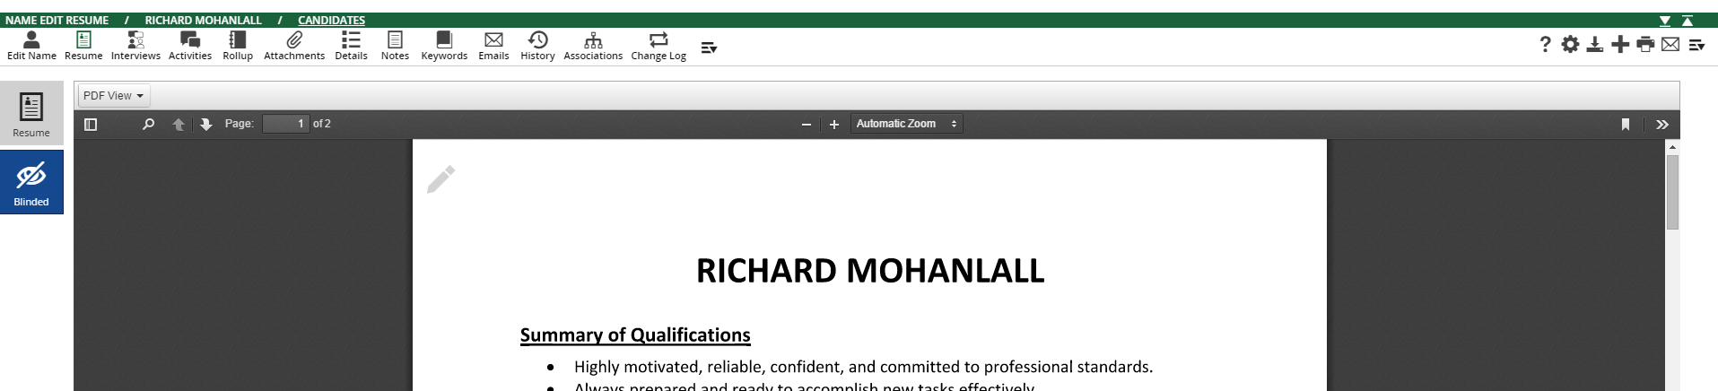
4. In the Email section, enter the recipient’s email address, or click the icon to the right of the field to search your database by name to find an email address. Enter the subject and content for the email.
5. Click Send Options for meeting request, encoding, return receipt, importance, private email, header/footer, send as PDF, and resume feedback options.
6. Click Attachments to select and upload files stored on your computer as attachments to the email.
7. Click PCR Files to select PCR global attachments or files stored with the candidate’s name record as attachments to the email.
8. Click Send.
Add Your Jobs
These are your clients’ job opportunities/searches for clients
1. Click the Company icon on your Main Toolbar to open your Company Menu
2. Use the search area to find and open the company for which you have a new position.
3. Click the Positions icon on the Edit Company toolbar.
4. Click the Add New Position action icon.
5. Enter details about the job in the “Internal Job Description” box. This will not be seen on our website, and you may put info in this box that you would like internal RIM recruiters to have access to. This is what will be seen when you send an internal job-blast. 6. Verify that that the Number of Openings field is 1 or greater, the position’s Status is Available/Open.
7. To show on website: If you would like the job to be visible on our website, ensure that the “Job Description” box is complete and the “Show on Web” field is set to ‘Show’. If you would not like your job posted externally, ensure that the “Show on Web” box is not ticked.
8. Click Save.

Note: You may also use the “Add Wizard” located at the top right of your PCR screen to add a new job/position to PCR.

The following is a sample of the basic format that RIM uses for jobs posted externally:

About Our Client
Our client, a large hi-tech company located near downtown Toronto, is currently seeking a Senior Financial Analyst in a fast-growing sector of their business. This exciting role will offer the chosen candidate a positive work environment, excellent compensation and the opportunity for growth, along with a very good benefits package.

Responsibilities
- Analyzing business cases
- Evaluating pricing for large clients and capital projects
- Risk assessment and analysis
- Working closely with the sales/marketing team and assisting them in securing new business and retaining existing business
- Developing analytic models in support of pricing initiatives
- Financial modeling and analysis

Qualifications
- An MBA degree or CPA/CMA designation, or equivalent
- Prior experience working in a high-tech or telecommunications-related industry
- A minimum of 5+ years’ experience performing advanced data analysis and/or financial modeling
- Advanced Excel knowledge
- Experience with project management
- Excellent communication and interpersonal skills and the ability to work within tight deadlines in a fast-paced environment.

How To Apply
To apply to this exciting opportunity, please click the apply button below.

Instructions to send job blast to internal users

When in a job position (in the edit position screen), simply go to the right of the screen and click on the email icon (an envelope). It should pop-up a template with your INTERNAL job posting. The subject heading will be your job title and reference id.

If you are happy with it, in the "to" field:, just type the following email: allstaff@recruitinginmotion.com . This will send to all-staff currently working in any of the Recruiting in Motion offices.

If you would only like to send it to selected internal staff, feel free to type the select staff names in the “to” field.
Using The Pipeline in a Job-Order

The pipeline records are the connection of a candidate to a job. The pipeline is used to track a candidate from interest to placement for a position. An auditable trail is created so you can view all of the candidates who have been associated with that position in any stage, and a complete history of their involvement.
The easy-to-use Pipeline provides a tree structure for managing candidates at each stage in the process.
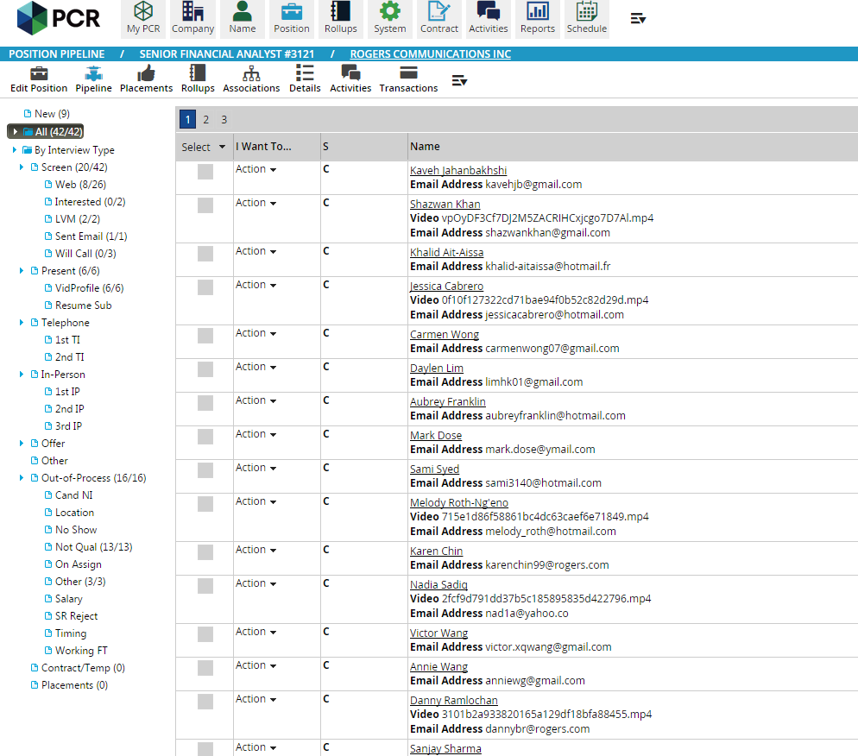
You will also find a “My Active Requisitions/Positions” option in the MyPCR welcome page that will present the Applicant List functionality for all of the current user’s open positions.

The above illustration is an example of a job's pipeline of candidates at various stages.

Drag-n-Drop in Pipeline
The drag-n-drop method allows you to quickly move a person to a stage in the job’s pipeline. Click on a name then drag and point to the folder to which the person should be moved. The candidate will be moved to the stage in the pipeline.

See above pipeline illustration to review current stages in the Recruiting in Motion pipeline.

Link Candidates to a Position
There are several convenient ways to associate a candidate with a position:
- A candidate can apply online through Recruiting in Motion’s website and be placed directly in the job’s pipeline through the PCR “Candidate Web Extensions.”
- When parsing a resume to create a candidate’s record, there is a Position picker to associate the candidate with a job.
- On a Name record, click the Link to Position action icon.
-On a Name record, click the Interviews icon then use the Add Interview action icon.
- In Name Search Results or Name Rollup, select records then use the Link to Position action icon.
- In a job’s Pipeline, click the Add action icon.

Candidates who apply to a job via the PCRecruiter Candidate Web Extensions will be linked to the job with the pipeline status ‘Web’ or ‘On-Line Job Inquiry’. The other methods will associate the candidate to the job with the pipeline status ‘LINKNAME’.

How to present candidate video profiles to clients

1. Before presenting any candidate to a client, please ensure that the "thoughtwire fields" section of the candidate profile is complete and that the candidate video has been uploaded. Also, ensure that the candidate has an MS-Word "Blinded Resume" uploaded in the "Blinded Resume" section of the resume tab, and that it is watermarked. This is the resume that the client will see. Note: It cannot be a PDF; it must be a Word document.

2. IMPORTANT: Input a “Password” for your client in their name record. The password field is the last field located under the “Thoughtwire/Video” fields. If the client has already been given a password, ensure you know what it is as you will be providing it to the client. To input a password, click on the password field and you will see a key to the right of the input box. Click on the key and a dialogue box will popup. Enter the password there. Then hit save. When you refresh the screen, the password will be shown in the password field.

3. When in a position/job order screen, click the pipeline icon. This will allow you to see your job's "pipeline".

4. For candidates to be viewable to a client, drag the candidates’ profiles to the area of the pipeline titled: "Vid Profile". It is under the pipeline category "Present".

5. When you are ready to inform your client that the candidates are available to be seen, click on the dropdown area of any candidate's summary area. The dropdown area is next to the word "Action" in the column titled "I want to...". In the dropdown, click "email". This will bring up an email screen with a pre-written template with instructions for your client to access the portal. The default email template should be populated on your screen, but if not, please choose the email template titled “Default”. You can perform this action from ANY of the candidates in the vid-profile section of the pipeline.

6. In this email, ensure that you provide the client his/her password (from step 2 above).

7. Feel free to tailor this email and add candidate-specific comments (i.e James Jones is available immediately and is looking for a minimum of $65K and would love the opportunity to work at ABC company...). You may also tailor the name and subject of the email.

8. When you hit send, this email will be sent to your client and all the candidates in the "Vid Profile" section of the pipeline can be seen online by your client.

How do I know what my client is actually seeing in their client portal?

1) Click this link to access the client portal: https://www2.pcrecruiter.net/pcrbin/employer.aspx?uid=recruiting%20in%20motion.recruitinginmotion

2) From this screen, enter your client’s email address and password that you have provided to them.

3) You now have access to view all of the jobs and candidates in their client portal.

Removing Candidate from the video-section of the client portal

Here's the quickest way to remove one candidate from the video-section of the client portal, without closing your job order:

1) Open the pipeline section of your active job-order, and in the left column locate the "VidProfile" section of the pipeline and click on it - here's a sample of what it looks like:

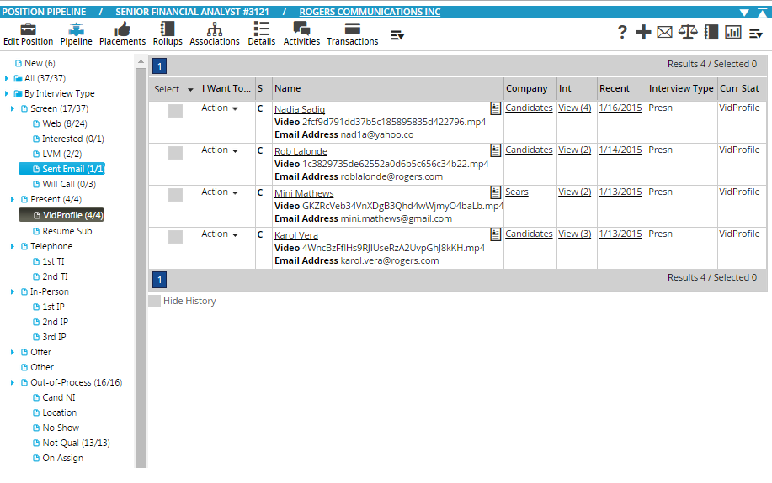

2) Locate the person you want to remove from view. In the above example we can choose Nadia Sadiq. You will notice that there is a column to the mid-right titled "Int", and in Nadia's row it shows "View(4)". Click on View(4) to see the events related to Nadia in this pipeline. They will look like this:

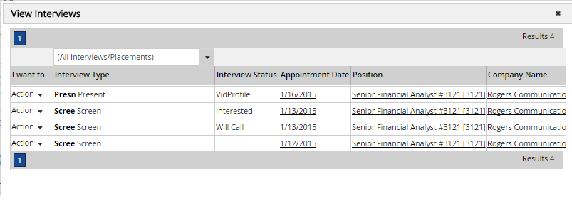

3) Under the column titled "interview status" you will see an event titled "VidProfile" and next to it the date that it was created. In this case: 1/16/2015. Click on the date and you will get the following screen:

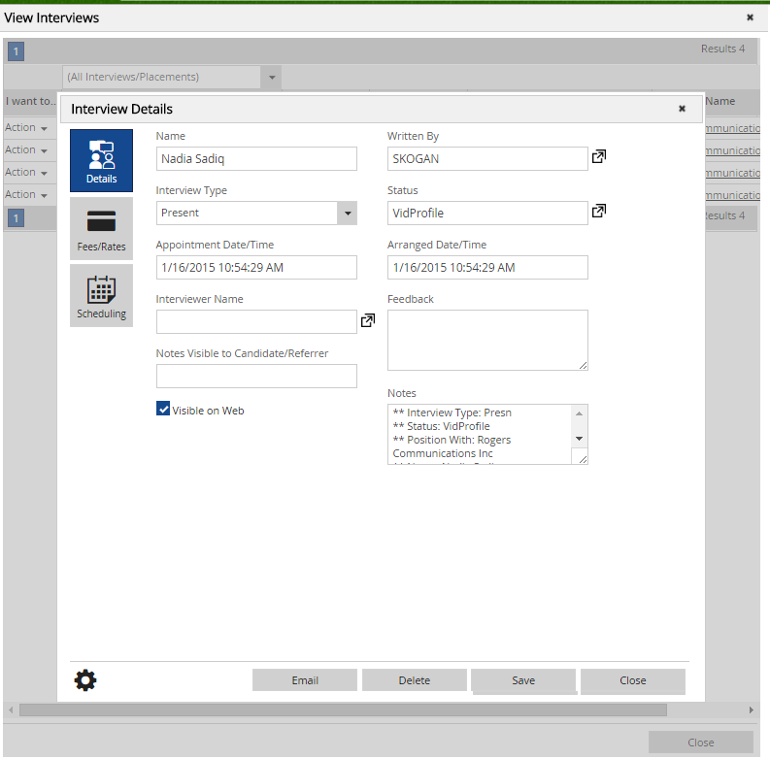

4) Near the bottom-left you will see a box with a tick mark saying "Visible on Web". UNTICK THIS BOX! Then click "Save" and "close".

5) If there are any other VidProfile events (as per #3 above). Perform the same exercise on those - but there likely was only one VidProfile event.

6) Your candidate is now still in the pipeline, but is no longer visible to your client.

Create an Interview
In addition to Drag-n-Drop Pipeline management, PCRecruiter allows for manually creating Interview records. Use this when you want to track the date of the interview and plan follow-up appointments to your Schedule.
1. Go to the Position record then click the Pipeline icon.
2. Do one of the following:
a. If the candidate is already associated with the job, go to the ‘I Want To…’ column. Click on Action then Add.
b. If the candidate is not associated with the job, click the Add action icon. Find the candidate by name then select the candidate.
3. Click the Interview Status picker to designate the type of interview to schedule.
4. Select a Date and Time when the interview will occur.
5. Click the Fees/Rates charm at the left and modify as necessary.
6. Click the Scheduling charm at the left to place a follow up appointment on your schedule, or place prep and debrief appointments on your schedule.
7. Click the Email charm and the left for ‘quick email’ options. Please note that if you prefer to view and edit the content before sending or pick attachments, a different email function will be available after the interview is saved.
8. Click Save. Once the interview is saved, you will have an Email option at the bottom right to compose an email.

Please note that you may also create an interview record by going to the candidate’s Name record then clicking the Interviews icon.

PCR Searching – Name Search, Company Search & Position Search

Basic Search
There are two types of data you can search: fields and indexed text. Examples of fields are First Name, Last Name, Title, State, etc. Indexed Text are your Resumes, Notes, Keywords, Summary, Candidate Profiles, and Job Descriptions.

1. Click the Company, Name or Position icon on the Main Toolbar depending on the type of record. This will display a search form in which you can filter your search using up to three fields and/or keywords.

2. Three fields will display by default. To search a different field, use the dropdown to find and select the desired field.

3. Enter the value to search in the field to the right.

4. Enter search terms in the box to filter by indexed text.

5. Click Search. If you searched indexed text your results will sort by relevancy to the search terms.

Tips for searching fields:

-By default, PCRecruiter will find results that start with the value you enter. Use percentage symbol (%) before the value to search fields that contain the value rather than starts with. For example, searching the Title field %engineer will produce names where Engineer and Director of Engineering are in the title.

-Use a comma to separate multiple values when field searching. For example, you can search the city field for Toronto, Mississauga, Etobicoke

-You can also use a combination of commas and percentages. For example: %HR,%human resources

Tips for searching indexed text:
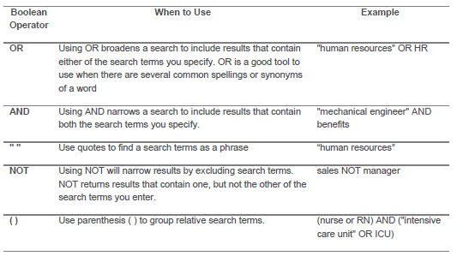

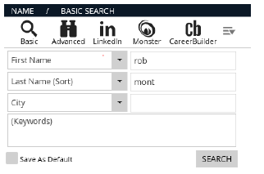

Example 6 - above: Finding a record by Name. This example would return any name record where the first name starts with rob and the last name starts with mon.

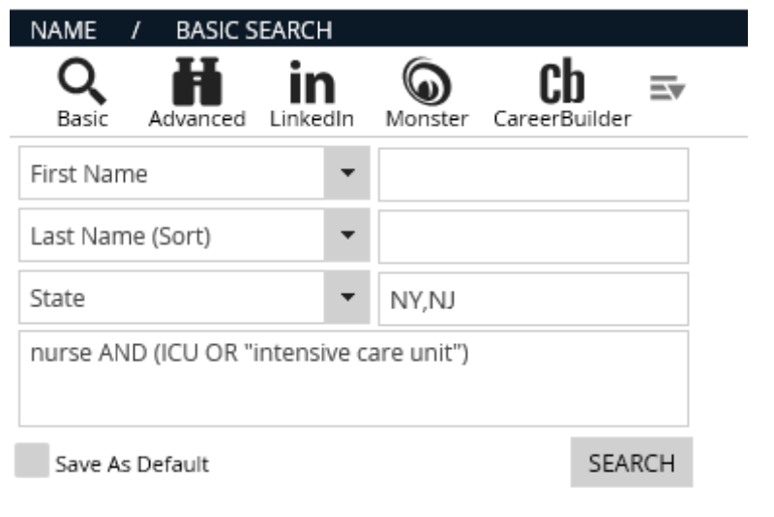
Example 7 – above. Finding names where the state is NY or NJ. There is no space after the comma. The text box is used to further narrow the results to Nurse. In addition the indexed text will have either ICU or the phrase Intensive Care Unit.

Advanced Search
Advanced Search allows you to perform more complex searches than Basic Search. Use Advanced Search when, you need to:

-Search more than 3 fields
-Compare results against the search value (i.e. greater than, less than, or equal to a value).
-Find records where the field is not like, empty, or is not empty.
-Find name records based on the History fields.
-Narrow results based on radius to a zip or postal code
-Save search criteria for future use
-Return records that are on or not on a rollup list

1. Click the Company, Name or Position icon on the Main Toolbar depending on the type of record.

2. Click the Advanced icon.

3. Use the first dropdown to specify where to search:
- When select Predefined Fields, Custom Fields, or History Fields. Use the second dropdown to select the field to search, the third dropdown to specify how to search (i.e. LIKE or Greater Than/Equal). Enter the value to search in the last box. For many fields you can use the selector to the right of the last box to select from values currently in use for your database. Click Add to add the selections to the query box.
- When select Zipcode Radius, click the icon to the right of the second field. Select the Country, location, and radius then click Search. Zip codes will be listed. Click Select Items and Continue. Click Add to add the selection to the query box.
- When select to filter based on Rollup, select if you want records On/Not On List, then use the arrow to view a listing of rollups. Click the desired rollup list. Click Add to add the selection to the query box.

4. Enter search terms in the Keywords box to filter by indexed text.

5. Click the Search action icon. If you included keywords in your search the results will sort by relevancy to the search terms. You can use the action icons in the search results to rollup into a list, mass email, or link to a position.

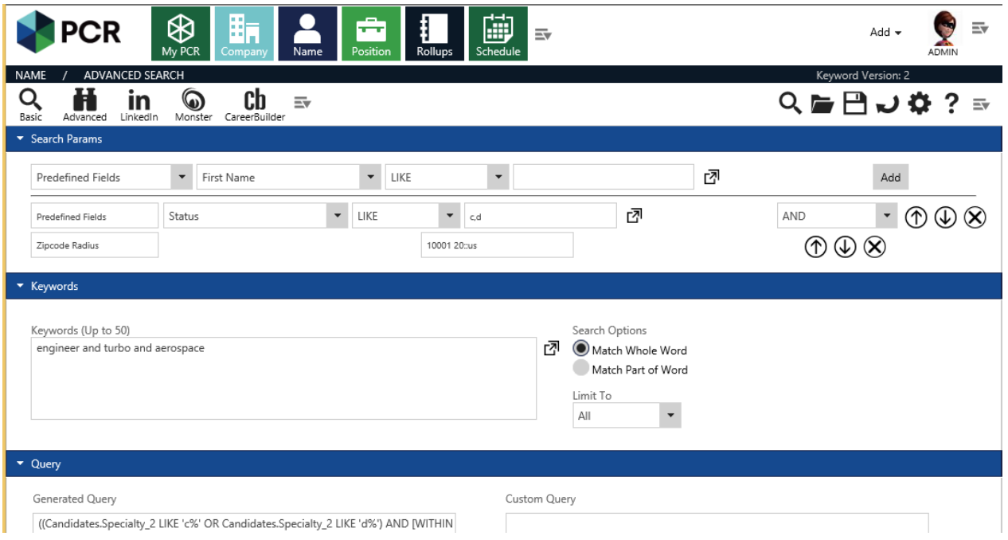

Example 8 – see above. Advanced Name Search to find names based on Status field, zip code radius, and keywords.

Activities Search
The Activities icon on the Main Toolbar provides abilities to search:
- Company Activities,
- Name Activities,
- Position Activities, and
- Interviews (online inquiries, submittals, interviews, placements).

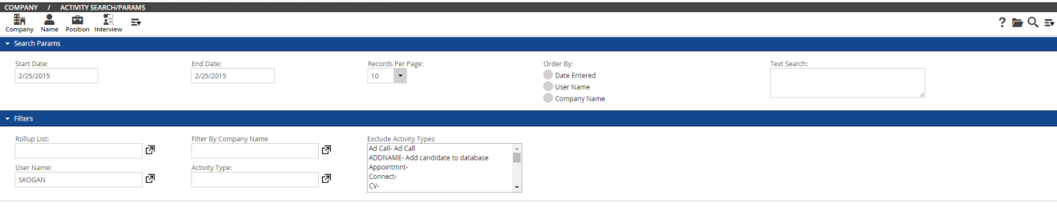

(Note: Above illustration shows a company activities search screen.)

Rollup Lists
Rollups are a list of Company, Name or Position records. These records are grouped together for a variety of reasons including but not limited to:
- Call Planning
- Imported from same file
- Records to be mass updated or deleted
- Reporting needs
- Bulk Email Campaigns

Add a Rollup
1. Click the Rollup icon on the Main toolbar.
2. Click the Add action icon.
3. Enter a Description (up to 20 characters)
4. Select a Category (Optional). Category is helpful for categorizing lists.
5. Modify the User Created and Owner Name fields if necessary.
6. Switch Shared to No if other users should not have access to open the list.
7. Specify a Default Activity Type (this step is normally skipped unless using an Activity Type/Result activity setup)
8. Enter a Memo (provide a description of the contents or purpose of the list)
9. Click Save.

Add a Record to a Rollup
1. Go to the Company, Name, or Position record
2. Click the Add to Rollup action icon, or go to the Rollup icon then and select Add.
3. Click on the name of the rollup. The record is on the list.
4. View the list, add to another list, or click Close.

Add a Group of Records to a Rollup
1. Perform a search of the records.
2. Select records.
3. Click the Add to Rollup action icon.
4. Click on the name of the rollup. The records are on the list.
5. View the list, add to another list, or click Close.

Access a Rollup List
1. Click the Rollup icon on the Main toolbar.
2. Click on the Rollup Name and you’ll enter the Rollup list.
3. Click the Company, Name, or Position icon to toggle the Rollup View (icon to click depends on the type of records added to the list).

Use a Rollup List to Review & Call
A Rollup List is most often created after performing a search. For example, you can run a search to find a list of names for networking based on skills and geography then “roll” the results into a list.

For each type of Rollup (Company, Name or Position), you can apply statuses and stages to as visual indicators to denote where the related record is in your process. You can also access the records to quickly record activities, add notes, link a person to a position, schedule interview, etc.

Rollup Stages can be customized by user and copied to other users. Additionally, Stages can be configured to automatically write an Activity, pop up the New Activity window, or run an Automation Plan.

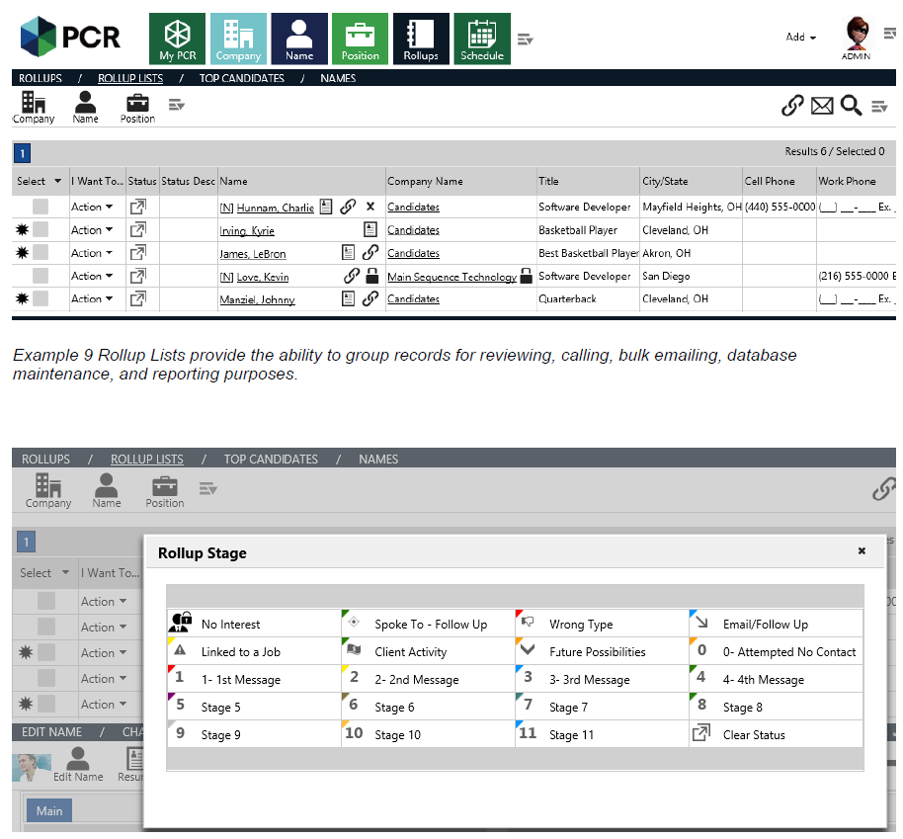

Example: Rollup Stages allow you to select visual indicators as you work through your list. This is an example of a customized setup.

Add a Permanent Placement
1. Open the Position record.
2. Click the Placements icon.
3. Click the Add Permanent Placement action icon.
4. In the Details section, select the name of the candidate, Start Date, and Placement Date using the picker for each field.
5. Click the Fees/Rates icon to enter starting salary and fee information.
6. Click the Schedule icon to schedule appointments before, on, or after the start date.
7. Click Place to save.

Once the Permanent Placement is saved, the following will happen:

-The Candidate is moved to the Placement folder of the job’s Pipeline

-An activity is created and attached to the candidate, company and position. This activity provides the details of the placement.

-The Number of Openings field on the Position Record is reduced by 1.

-If there was one opening, the job’s Status will automatically change to Filled, and will be excluded from your Candidate Web Extensions.

-The candidate will become associated with the position’s company and inherit the Status of Placed.

- The candidate’s Name record will also inherit the Starting Salary as Current Salary, and the Job Title of the position’s Job Title.

Add a Contract/Temp Placement
1. Open the Position record.
2. Click the Placements icon.
3. Click the Add Contract/Temp Placement action icon.
4. In the Details section, select the name of the candidate, Start Date, End Date, and Arranged Date using the picker for each field.
5. Click the Fees/Rates icon to enter bill rates, pay rates, per diem, and burden information.
6. Click the Schedule icon to schedule appointments before, on, or after the start date.
7. Click the Timesheets icon to specify pay period, approver(s), begin day, and time clock
preference for this assignment.
8. Click Place to save.

Once the Contract/Temp Placement is saved, the following will happen:

-The candidate is moved to the 'Contract/Temp' folder of the job’s Pipeline.

-An activity is created and attached to the contractor, company and position. This activity provides the details of the placement.

-The contractor will inherit the Status of ‘Contract/Temp until the assignment begins. The End Date of the Assignment will be added to the Available field on the contractor’s Name record. On the Begin Date, the contract’s Status automatically changes to "On Assignment" for the duration of the assignment. If at any time the duration changes, you will need to change the End Date in the Contract/Temp Placement record.

-The number of openings on the Position record is reduced by 1.

-If there was one opening, the job’s Status will automatically change to Filled, and will be excluded from your Candidate Web Extensions.

APPENDIX (Ideas/Topics to include in this guide):

 | Completed?
Getting Started with PCR | yes
Name Records (Candidates/Contacts):
Parsing resume through email | yes
Parsing resume through resume in folder | yes
Parse resume and associate name with a company | yes
Add name records with “Add Wizard” | yes
Adding name records (with no resume) | yes
Adding records through Linkedin/Facebook/Indeed | yes
Adding Notes to candidate files | yes
Adding blinded Resumes (to be presented to clients) | yes
Attaching files to Name records | yes
Candidate Activities:
Calling/tracking/update calls | yes
Call planning / preplanning/ rollups | yes
Emailing from within PCR | yes
Email campaigns / bulk email | yes
Job-related candidate activity calls (see jobs-section below) | yes
Companies/Marketing Activities:
Adding a company to PCR | yes
Moving Employee to another company | yes
Creating a company Target List | yes
Presenting a candidate video through MPC Presentation (no resume) | yes
Presenting a sample candidate video (i.e. George Shin video) | yes
Emailing a resume (no video) | yes
Email campaigns / bulk email (please refer to “Name Records” section) | yes
Rollups:
Creating a rollup | yes
Modifying a rollup | yes
Using rollups to develop call lists/email lists | yes
Job Orders:
Adding job orders | yes
Posting Jobs to website | yes
Linking candidates to a position | yes
Using the drag-n-drop activity pipeline | yes
Presenting candidate vid-profiles to clients | yes
Access to the client vid-profile portal | yes
Removing candidates from vid-section of the client portal | yes
Job-related candidate activity calls | yes
Sending job blasts to internal users | yes
Searching
Searching: Basic (name/company/position) | yes
Searching: Advanced (name/company/position) | yes
Searching: Tips and tricks (name/company/position) | partial
Activities Search | yes
Placements:
Perm placements | yes
Inputting Contract/temp placement | yes
Inputting Splits | Not Complete
Billing/invoicing | Not Complete
Reports:
To Be Added | Not Complete

